Instruction to run the file:

**KMeans**

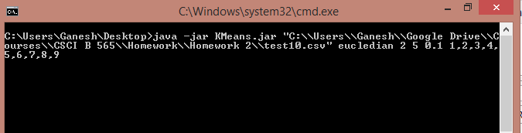

Java –jar Means.jar "C:\\Users\\Ganesh\\Google Drive\\Courses\\CSCI B 565\\Homework\\Homework 2\\test10.csv" eucledian 2 5 0.1 1,2,3,4,5,6,7,8,9

**For CF Calidation**

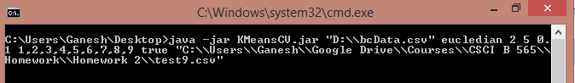

Java –jar Means.jar “D:\\bcData.csv” eucledian 2 5 0.1 1,2,3,4,5,6,7,8,9 true "C:\\Users\\Ganesh\\Google Drive\\Courses\\CSCI B 565\\Homework\\Homework 2\\test10.csv"